Wheelchair Positioning Evaluation and Prescription Form

Please complete this form entirely. Leave no spaces blank. Missing information will result in delays and denials.
Date: ___/___/____ Beneficiary Name: _____________________ DOB: ___/___/_____
Beneficiary Medicaid Number: ___________ Beneficiary Address: ________________________
Evaluator Name: __________________________
Evaluator Phone: __________________________
Evaluator Email: __________________________
Evaluator Facility: __________________________
Insurance(s): __________________________ Policy #: __________________________
Medical Conditions (include onset dates): __________________________
__________________________________________________________________________________________
__________________________________________________________________________________________

Wheelchair evaluation referral date: (this is the date the referring provider first requested a wheelchair evaluation): ___/___/____
FUNCTIONAL LEVELS

Bed Mobility: _________________________________________________________________________
Transfers
Technique: _____________________________________________________________________
Assist Level: ____________________________________________________________________
Ambulation:
Distance: _____________________________________________________________________
Devices: _______________________________________________________________________
Assist:________________________________________________________________________
Propulsion technique
Limbs used: ___________________________________________________________________
Equipment needed: ______________________________________________________________
(Over 21 only):
Check the mobility related activities of daily living (MRADLs) that cannot be accomplished without the requested device.
☐ Feeding ☐ Dressing ☐ Grooming ☐ Bathing ☐ Hygiene (toileting)
Check the nature of the mobility limitation that significantly impairs the ability to participate in MRADL activity:
☐ Prevents the accomplishment of the MRADL(s)
☐ Places the patient at reasonably heightened risk of morbidity or mortality in the attempt to perform MRADL(s)
☐ Prevents completion of the MRADL(s) in a reasonable time frame
☐ Check if the beneficiary is unable to access authorized medical transportation to medical services without the requested device
☐ Check if the beneficiary cannot functionally ambulate within the environments in which MRADLs are performed
Comments: __________________________________________________________________________ __________________________________________________________________________________________
__________________________________________________________________________________________
__________________________________________________________________________________________

MEDICAL STATUS

Medications: __________________________________________________________________________
Cardiovascular/Pulmonary: ______________________________________________________________
Sensory (vision, hearing, tactile): ________________________________________________________
Musculoskeletal: ______________________________________________________________________
Neurological (including seizure): _________________________________________________________
Cognitive: __________________________________________________________________________
Communication: ______________________________________________________________________
Integumentary: ________________________________________________________________________

PSYCHOSOCIAL

School/Employment: ___________________________________________________________________
Transportation system to medically necessary appointments: __________________________________
__________________________________________________________________________________________
If a personally owned vehicle and assistance is required for securing the wheelchair, are there consistent care providers available? ☐ Yes ☐ No ☐ N/A
Transported in wheelchair to medically necessary appointments? ☐ Yes ☐ No
If the chair will be used as a seat during transport:
Is there access to the structural frame of the wheelchair? ☐ Yes ☐ No ☐ N/A
Are there components that interfere with utilizing the wheelchair frame for securing the chair in the vehicle?
☐ Yes ☐ No ☐ N/A Explain: _______________________
Prescribed chair fits into transportation to medically necessary appointments? ☐ Yes ☐ No
Ramp slope into van: ☐ 1:12 (4.5 degree) ☐ 1:10 (6 degree) ☐ 1:8 (7.5 degree) ☐ 1:6 (9 degree) ☐ N/A ☐ Other __________________________
Head clearance into vehicle (with tilt if applicable): ☐ Yes ☐ No
Method of chair transport (e.g. car topper, fold in rear seat, transit brackets): ______________________________________________________________________________________________________________________________________________________________________________

HOME VISIT INFORMATION
Home visits performed by the prescribing therapist, either in person or via telemedicine, are strongly recommended to ensure that the requested device is appropriate for the MRADL(s) environment.
Home entry/exit (ramp slope, stairs): __________________________
Terrain to medically necessary transportation:
Distance: __________________________ Conditions: __________________________
Obstacle heights: _______________________ Slope: ________________________
Seasonal conditions: _________________________________________________________
Threshold height: _____________________ Floor conditions: __________________________
Ramp Slope into Home: ☐ 1:12 (4.5 degree) ☐ 1:10 (6 degree) ☐ 1:8 (7.5 degree) ☐ 1:6 (9 degree) ☐ N/A ☐ Other: __________________________
Turning radius needed in home: __________________________
Turning radius of wheelchair: __________________________
Door width:
Exit: _________________ Bedroom: ______________ Bathroom: ______________
Width of prescribed chair: __________________________
Distances to exit: __________________________
Is the chair suitable for use in the home environment? (Over 21 only) ☐ Yes ☐ No
If not, explain extenuating circumstances:
______________________________________________________________________________________________________________________________________________________________________________
Terrain at/and surrounding school/employment and community (Under 21 only): _____________________________________________________________________________________
Community transportation (Under 21 only – e.g. school bus): ______________________________________________________________________________________________________________________________________________________________________________

MEASUREMENTS

Height: __________________________ Weight: __________________________
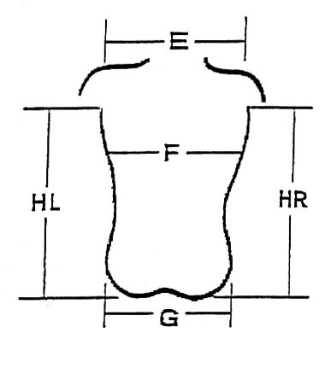
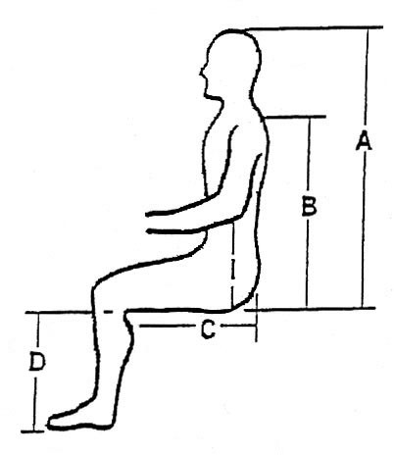
A ________ F ________

B ________ G ________

C ________ HR ________

D ________ HL ________

E ________ I ________

MUSCULOSKELETAL EVALUATION

L R
ROM/Strength: hip flexion _____ _____
hip abd. _____ _____
hip add. _____ _____
hip internal r. _____ _____
hip external r._____ _____
knee ext. _____ _____
knee flex. _____ _____
ankle DF _____ _____
other ___ _____ _____

Mobility related issues:
Trunk: ____________________________________________________________________________________
Pelvis: ____________________________________________________________________________________
Upper extremity: _______________________________________________________________________
Head control: ___________________________________________________________________________
Sitting balance: _______________________________________________________________________
Postural Influences (tone, reflexes): ______________________________________________________
Current Mobility Equipment:
Type: _______________________________________________________________________________
Age: ______________
Condition: ___________________________________________________________________________
Previous Coverage Source: ______________________________________________________________
Plan for disposal of the previous device if the requested device is authorized: ______________________________________________________________________________________________________________________________________________________________________________
_____________________________________________________________________________________
Assessment: (You may also attach clinic note and supporting documentation.) ______________________________________________________________________________________________________________________________________________________________________________

WHEELCHAIR PRESCRIPTION

Wheelchair Components:

Base: (Check one)
Manual wheelchairs:
☐ Standard
☐ Standard hemi height
☐ Lightweight
☐ High strength, lightweight
☐ Ultra-lightweight
☐ Heavy duty
☐ Extra heavy duty
☐ Tilt in space
☐ Recliner, full
☐ Recliner, semi
☐ Pediatric wheelchair/stroller
Power Operated Vehicles:
☐ Group 1
☐ Group 2

Power Wheelchairs:
☐ Group 1
☐ Group 2
☐ Group 3
☐ Group 4
☐ Group 5

Options - Power Wheelchairs:
(Check all that apply)
☐ Elevating leg rests
☐ Power tilt
☐ Power recline
☐ Other: ______________

Wheelchair and Components: (provide medical necessity justification for each component)
Component | Specifications | Medical Necessity Justification
Base Chair: review definitions in the Appendix (see wheelchair packet) | __________________________ | __________________________
Frame Size | __________________________ | __________________________
Back | __________________________ | __________________________
Seat | __________________________ | __________________________
Arm | __________________________ | __________________________
Front Rigging | __________________________ | __________________________
Drive Wheels | __________________________ | __________________________
Casters | __________________________ | __________________________
Wheel Locks | __________________________ | __________________________
Interface (power chair) | __________________________ | __________________________
Electronics (ex: controllers, power seating functions) | __________________________ | __________________________
Other | __________________________ | __________________________

Assembly Instructions:
______________________________________________________________________________________________________________________________________________________________________________________________________________________________________________________________________________________________________________________________________________________________________________________________________________________________________________________________________________________________________________________________________________________________________________________________________________

Seating Components: (provide medical necessity justification for each component)
Component | Specifications | Medical Necessity Justification
Seat (including cushion) | __________________________ | __________________________
Back (including cushion) | __________________________ | __________________________
Trunk | __________________________ | __________________________
Head | __________________________ | __________________________
Upper Extremity | __________________________ | __________________________
Lower Extremity | __________________________ | __________________________
Other | __________________________ | __________________________

Cost Comparison:
Medicaid requires that there be coverage for the least expensive, medically necessary device (Medicaid Rule 7102.2). Document that EACH of the following devices were considered/trialed and deemed not medically appropriate for the recipient. Please provide rationale:
Cane/Crutches: ___________________________________________________________________
Walker: ______________________________________________________________________
Manual wheelchair (if requesting power device): ________________________________________
Lesser manual wheelchair (if requesting a manual device): ________________________________
Power operated vehicle (scooter) (if requesting power wheelchair): ________________________________________________________________________________
Lesser Group Power wheelchair: _____________________________________________________

