PLAIN TEXT: Electronic Visit Verification (EVV)
What Does EVV Mean For You?

Overview of Webinar
- Overview of Electronic Visit Verification (EVV).
- What does EVV mean for the people you support.
- Review of on-demand training and resources.
- Opportunity for participants to ask questions of hosts.
- Please keep your microphone muted and camera turned off during overview portion, during other participant’s questions and hosts’ responses.

Quick Introduction to EVV
To view an animation showing a care provider using EVV during an in-home visit, click the following link.

https://www.youtube.com/watch?v=HxMknzrZec8

What is EVV
- EVV is a telephone and computer-based system that records visit information for those receiving home-based care paid by Medicaid.
- Care Providers can use a smartphone app or a landline phone to record the time they start and end personal care visits.
- Employers will use an EVV website to review, correct, and approve these visit details for payment.
- EVV has been a federal requirement since January 1, 2021

When is EVV Required?
- EVV is required for:
  - Adult Services Program (ASP-General Fund)
  - Adult Services Program (ASP-Medicaid PDAC)
  - Choices for Care (CFC High/Highest)
  - Children’s Personal Care (CPCS)
  - Flexible Choices
  - Moderate Needs Group
  - Brain Injury - Respite
- EVV is required when services are provided in the participant’s home or when home-based care starts or ends in the community.

When is EVV NOT Required?
- EVV is not required when:
  - Services are provided entirely outside the participant’s home, or
  - The caregiver lives in the same home as the recipient.
- Services that do not require EVV are known as “EVV Exempt”.

How Do I Tell ARIS That EVV is Not Required on E-Timesheets
- Information about EVV Exempt Status must be reported on every timesheet.
- If you use eTimesheets, employers/employees will check this box, if the entire timesheet is EVV Exempt.
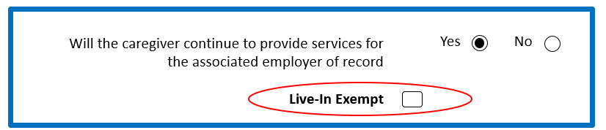

How Do I Tell ARIS That EVV is Not Required on Paper Timesheets
- If they use paper timesheets, they must answer this question, every time.
- If the caregiver lives in the same home as the person receiving care, then EVV is not required.
- Services provided entirely outside of the participant’s home should be marked as “community”.

Employee’s EVV: Easy as 1…2…3!
- Learn about EVV and how to log the work
  - There is on-demand training available to learn at an employee’s own pace.
- Download the app, so employees can log visits using a smartphone
  - If you do not have a smartphone, there is a toll-free number you can use to log your visits.
- Start using EVV for all services provided in the participant’s home.
  - Employees can log all the services that they provide, but the ones that are provided in the home must have a matching EVV record.

Employer’s EVV: Easy as 1…2…3!
- Determine if EVV is required
  - If EVV is required, employers cannot be excused from doing it.
- Access on-demand training to learn at an employer’s own pace.
- Perform visit maintenance as needed
  - The employee will use the EVV system to log shifts worked, but it is the employer’s job to be sure that they do and that the information is correct.
  - Verified and corrected visits that have been updated by the end of each workweek will be automatically transferred to eTimesheets.

Don’t Forget the Timesheet
- EVV is like a time clock.
- For ARIS to process payment, we must receive a timesheet.
- EVV does NOT replace a timesheet—but EVV does send information to ARIS’ eTimesheet system.

EVV and eTimesheets
- EVV sends visit information to eTimesheets
  - At the end of each workweek, EVV send verified visit information to eTimesheets.
  - eTimesheets notifies the Employer that a timesheet has been created.
  - The eTimesheet needs some additional information to be complete.
  - It is still approved by both Employer and Employee before it is submitted.
- eTimesheets are not required; paper timesheets can still be submitted.

Where Do I Go to Learn More?
- The ARIS homepage includes a link to EVV training resources www.arissolutions.org.
- This link will take you to Employer and Employee on-demand training videos.
- Let's review the website together!!
- Note: The live webinar presentation includes a real-time review of the online training material.

On-Demand Training
- Allows learning at an individual’s own pace and through a variety of learning options.
  - Including recorded webinars and how-to videos, user manuals and easy to follow quick reference guides.
- To access on-demand training, visit the ARIS website www.arissolutions.org and click on the EVV icon.

Where Do I Go for Help?
- ARIS has specially trained EVV staff.
- Contact ARIS Solutions
  - Call (800) 798-1658 option 2
  - Email evv@arissolutions.org

Time for Questions
  - Please “raise your hand” to show you have a question.
  - We will ask you to unmute your microphone and ask a question.
  - Please do not use any use any personal identifying information.
  - A REMINDER: Participants are responsible for ensuring that no confidential information is presented or discussed in the meeting and associated materials

