
Department of Vermont Health Access
Agency of Human Services

DVHA: Asthma Prevention Guidelines
Introduction | 1
Overview of Disease State and Prevalence | 2
- Part 1: Definition and Description of Asthma | 2
- Part 2: Diagnosis of Asthma | 3
Management and Prevention of Asthma Exacerbations and Hospitalizations | 4
- Part 1: Goals of Management | 4
- Part 2: Measuring Asthma Control | 6
- Part 3: Identifying Asthma Severity and Exacerbations | 6
- Part 4: Population Screening and Evaluation | 8
Treatment Regimens for Controlling Asthma | 9
- Part 1: Non-Pharmacologic Treatment | 9
- Part 2: Medications Options for Treatment | 10
- Part 3: Medication Regimens and Step Approach to Asthma Management | 12
Asthma Statistics, Clinical Data, and Recorded Measures for Disease Evaluation | 16
- Part 1 Vermont Medicaid Global Commitment to Health Measures | 16
- Part 2: Prevalence and Hospitalization Rates | 16
- Part 3: Vermont Department of Health, Asthma Statistics | 17
Guidelines and Updates | 18
- Part 1: Approved Guidelines for Asthma Prevention and Treatment | 18
- Part 2: Biologic Medications on Medicaid Preferred Drug List and Clinical Efficacy | 19
- Part 3: Vermont Medicaid Nonpharmacologic Guideline Supported Care Coverage | 21
References | 22
Introduction:
Asthma is one of the nation’s most common chronic conditions. Managing asthma and reducing its burden calls for long-term, multifaceted approaches that include patient and provider education, behavioral changes, trigger avoidance, pharmacological therapy, medical follow-ups, and the development of best practices using proven and updated medical research.
Overview of Disease State and Prevalence:
Part 1: Definition and Description of Asthma
Definition:
- From the United States Department of Health and Human Services (USDHHS) National Institutes of Health (NIH) National Heart, Lung, and Blood Institute (NHLBI) National Asthma Education and Prevention Program’s (NAEPP) Expert Panel Report (EPR) 3: Guidelines for the Diagnosis and Management of Asthma (2007):
Asthma is a chronic inflammatory disorder of the airways in which many cells and cellular elements play a role: in particular, mast cells, eosinophils, T lymphocytes, macrophages, neutrophils, and epithelial cells. In susceptible individuals, this inflammation causes recurrent episodes of wheezing, breathlessness, chest tightness, and coughing, particularly at night or in the early morning. These episodes are usually associated with widespread but variable airflow obstruction that is often reversible either spontaneously or with treatment. The inflammation also causes an associated increase in the existing bronchial hyperresponsiveness to a variety of stimuli. Reversibility of airflow limitation may be incomplete in some patients with asthma (p. 14).
- From the Global Strategy for Asthma Management and Prevention report (GINA, 2022):
Asthma is a heterogeneous disease, usually characterized by chronic airway inflammation. It is defined by the history of respiratory symptoms, such as wheeze, shortness of breath, chest tightness and cough, that vary over time and in intensity, together with variable expiratory airflow limitation (p. 20).
- From the Vermont Department of Health, (Asthma and Lung Disease, 2022), “Asthma is a chronic (long-term) disease in which the lungs become inflamed, and airways narrow and react to "triggers” (para. 1).
Description
- Inflammation of the airway is central to asthma. Airflow obstruction and increased sensitivity to a variety of stimuli or hyperresponsiveness are also key characteristic of asthma, Symptoms of asthma include shortness of breath, wheezing, chest tightness, cough, and impact to airflow on expiration (NAEPP, 2007).

Part 2: Diagnosis of Asthma
Initial Diagnosis
- In the process of making an initial diagnosis of asthma, the medical provider should use medical decision making to identify the following:
  - “Episodic symptoms of airflow obstruction are present.
  - Airflow obstruction is at least partially reversible.
  - Alternative diagnoses are excluded” (NAEPP, 2007, p. 40).
- Initial evaluation of asthma should also include:
  - Detailed medical history
    - Evaluate for history of symptoms including frequency and time of onset (e.g. daytime versus nighttime), worsening or aggravating factors, history around development of the disease, history of exacerbations, and effect on patient and family.
  - Physical exam with attention to the respiratory system and skin
    - Evaluate expansion of thorax, muscle use during breathing, shoulder position, and chest shape.
    - Assess for wheezing, changes to breathing pattern, nasal symptoms (runny nose, swelling of the nasal passage, polyps), indicators of allergic skin conditions.
  - Pulmonary function testing including the following spirometry measurements:
    - Forced expiratory volume in 1 second (FEV1), FEV6 (FEV over 6 seconds), forced vital capacity (FVC), FEV1/FVC both pre and post use of short acting bronchodilator
  - Additionally, the 2020 update to the NAEPP Expert Panel Recommendations conditionally recommend use of fractional exhaled nitro oxide (FeNO) measurement testing in patients “ages 5 and older when the diagnosis of asthma remains uncertain after collection of history, physical exam/clinical findings, and spirometry testing, or when spirometry is unable to be performed” (p. 31).
Differential Diagnosis
According to the NAEPP EPR 3 (2007), differential diagnoses should be considered and ruled out through review of medical history, physical exam and pulmonary function testing and incorporation of other testing as appropriate. This may include for example chest x-ray, biomarker testing, or allergy testing.
Other diagnoses that may be considered though not exhaustive include the below.
- Infants/children:
  - Upper airway diseases (e.g. allergic rhinitis)
  - Obstructive conditions of the large airways (e.g. laryngotracheomalacia)
  - Obstructive conditions of the small airways (e.g. viral bronchiolitis)
  - Other such as gastroesophageal reflux
- Adults:
  - Chronic obstructive pulmonary disease (COPD)
  - Heart Failure
  - Cough that may be related to a side effect of medications
Management and Prevention of Asthma Exacerbations and Hospitalizations:
Part 1: Goals of Management
- Helpful website links from our partners at the Vermont Department of Health and Vermont Medicaid
  - Asthma Facts for Individuals and Families: https://www.healthvermont.gov/wellness/asthma/asthma-facts-individuals-and-families
  - VDH VT Asthma Program: https://www.healthvermont.gov/wellness/asthma
  - Link to VT Medicaid website for finding pulmonary specialist http://vtmedicaid.com/#/providerLookup
  - Link to Asthma Action Plan Template Annual Asthma Action Plan_2016_08_26.pdf (healthvermont.gov)

- Per the NAEPP EPR 3 (2007), goals of asthma therapy are directed at management and good control. In order to maintain control, the 2007 Expert Panel Recommendations include periodic assessment and monitoring to include:
  - Reduce impairment
  - Reduce risk
  - Maintain periodic assessment and monitoring interventions
    - Clinician and patient self-assessment
    - Spirometry at recommended frequencies
    - Maintain a written asthma action plan (pp. 52-53).
- Per the Global Initiative for Asthma Global Strategy for Asthma Management and Prevention (2022), long-term asthma management is based upon long term goals including “to achieve good symptom control, and to minimize future risk of asthma related mortality, exacerbations, persistent air flow limitation and side effects of treatment. The patient’s own goals regarding their asthma and its treatment should also be identified” (p. 47).
- Organizations including the Centers for Disease Control and Prevention (CDC), the American Lung Association (ALA), and the Vermont Department of Health recommend that individuals with asthma should have an up-to-date Asthma Action Plan.
  - Plans help those with asthma understand and manage their asthma,
  - Helps to look for triggers that make asthma worse or cause attacks,
  - Remember instructions on management and what to do if worsening symptoms or an attack,
  - Know which medications to take and under which circumstances to take them,
  - Know when to contact doctor or go to emergency room
- One of the keys to managing and preventing asthma exacerbations is managing triggers (Asthma and Lung Disease, 2022).
  - Triggers are unique to the individual, so everyone must find their own.
    - Common Triggers:
      - Cold air
      - Exercise
      - Dust
      - Tobacco smoke
      - Pet dander
      - Indoor and outdoor air pollution
      - Viral illnesses such as cold and flu
      - And especially for children- strong emotions
  - Avoiding known triggers or managing being around them is a key to well managed asthma and avoiding attacks
- Environmental factors are also an important component to monitor to reduce exacerbations as seen in the following tables (Asthma Data Pages, 2022).
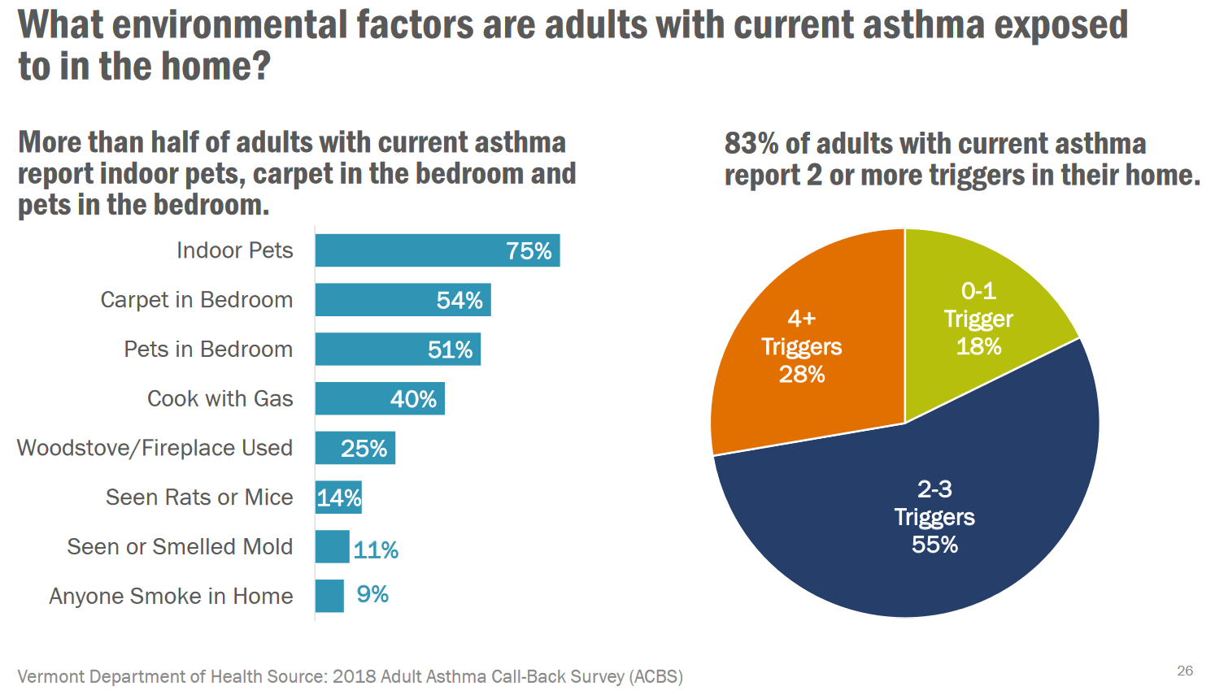
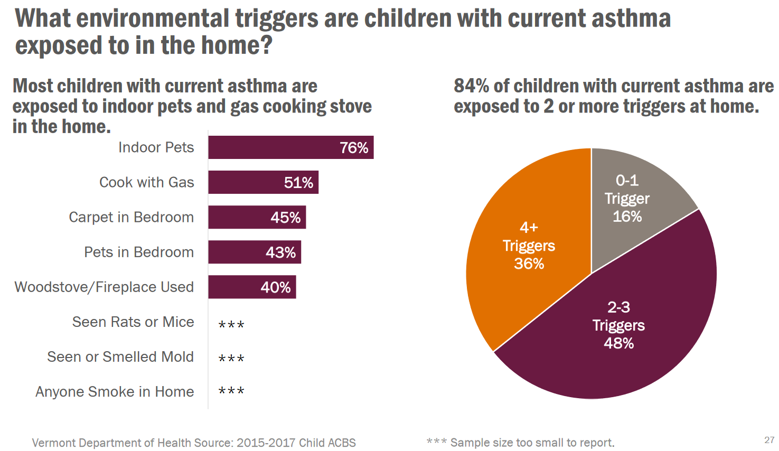

  - Vermont Department of Health has pamphlets available about asthma triggers along with tips and tricks that can be found and printed here: brochure_r3_4 (healthvermont.gov)
Part 2: Measuring Asthma Control
The NAEPP EPR 3 (2007) recommends several specific areas for monitoring asthma control:
- Signs and symptoms
- Pulmonary function including spirometry and peak flow monitoring
- Quality of life (measured via screening tools/questionnaires such as the Asthma Quality of Life Questionnaire (Juniper et al, 1999)
- History of asthma exacerbations
- Pharmacotherapy adherence
- Patient-provider communication and patient satisfaction with this
- Lower evidence recommendation is monitoring asthma control w/ minimally invasive biomarker testing
(P. 53).
Part 3: Identifying Asthma Severity and Exacerbations
- According to the CDC (2016), asthma control is based on 4 variables:
  - Symptoms
  - Nighttime awakenings
  - Interference with normal activity
  - Short acting beta agonist use
- Asthma is considered uncontrolled or poorly controlled when:
  - Symptoms are present >2 days per week
  - Nighttime awakenings occur
    - >1 time monthly for those aged 0-4
    - ≥2 times monthly for those aged 5-11
    - 1-3 times weekly for those aged 12+
  - Short Acting Beta Agonist inhaler(s) are used >2 times weekly
  - There are limitations with daily activities
- 41% of Vermont adults have uncontrolled asthma
- 25% of Vermont children have uncontrolled asthma
From the NAEPP EPR 3 (2007), asthma severity and level of control is broken down by age groups (pp. 72-77). The below charts help to identify asthma severity and control in the 12+ age group, which is also coincides with the most prevalent asthma population in Vermont. The CDC (2016) also has a helpful table of well controlled vs. poorly controlled asthma per age group that is based on these NAEEPP (2007) guidelines.

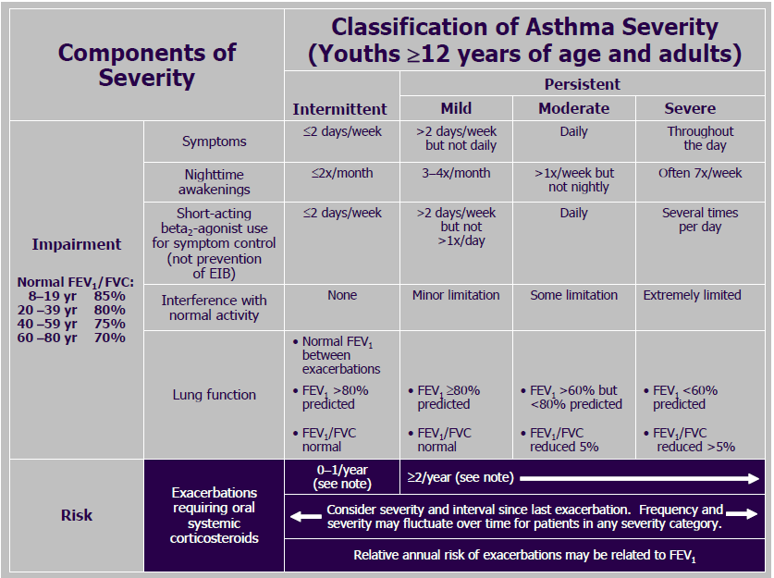
Note: From the NIHHS NIH NHLBI National Asthma Education Expert Panel Report 3: Guidelines for the Diagnosis and Management of Asthma (2007), p. 73, https://www.ncbi.nlm.nih.gov/books/NBK7232/pdf/Bookshelf_NBK7232.pdf

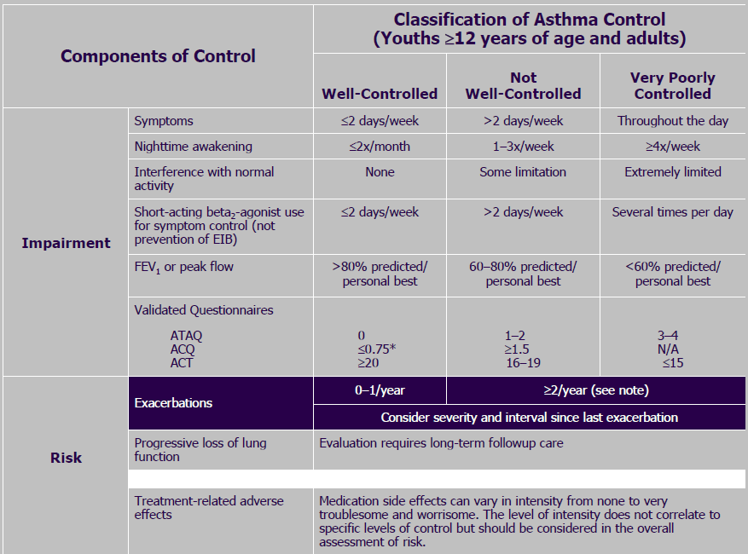
Note: From the NIHHS NIH NHLBI National Asthma Education Expert Panel Report 3: Guidelines for the Diagnosis and Management of Asthma (2007), p. 75, https://www.ncbi.nlm.nih.gov/books/NBK7232/pdf/Bookshelf_NBK7232.pdf

Part 4: Population Screening and Evaluation
The Guidelines for the diagnosis and management of asthma from the NIH NHLBI NAEPP Expert Panel Report 3 (2007) note that population-based assessment of asthma is of increased interest as large regulatory organizations such as the National Committee on Quality Assurance have included asthma in key quality measures for managed care (e.g. see Asthma Medication Ratio measure below). Population data including hospitalization or emergency department statistics are used to review care based on different settings and providers. According to the NIH guidelines, standardized population surveys are being tested experimentally in the managed care setting. (p. 68).
Efforts have been made to create quality care delivery standards for asthma including the Global Quality Standard for Identification and Management of Severe Asthma (Haughney et al., 2020) which cites the following 4 key elements to optimize management and outcomes: (1) coordination of services, (2) timely detection and referral of patients with severe asthma, (3) use of guideline-recommended assessments and therapies, and (4) integration of patient expectations and values when making treatment decisions (p. 2).
The NAEPP ERP 3 (2007) makes the following recommendation regarding visit frequency for patients with asthma:
- Patients who have intermittent, mild, or moderate persistent asthma (i.e., requiring steps 1, 2, 3, or 4 treatment) that has been under control for at least 3 months should be seen by a clinician about every 6 months.
- Patients who have uncontrolled and/or severe persistent asthma (i.e., requiring steps 5 or 6 treatment) and those who need additional supervision to help them follow their treatment plan should be seen more often (EPR⎯2 1997).
- The frequency of visits to a clinician for review of asthma control is a matter of clinical judgment. Clinical assessment of asthma should be obtained through medical history and physical examination with appropriate pulmonary function testing (p. 67).

From the Global Strategy for Asthma Management and Prevention (GINA, 2022) response to asthma treatment and review for adjustment should occur as follows:

Patients with asthma should be reviewed regularly to monitor their symptom control, risk factors and occurrence of exacerbations, as well as to document the response to any treatment changes. For most controller medications improvement begins within days of initiating treatment, but the full benefit may only be evident after 3–4 months. In severe and chronically under-treated disease, it may take longer.
All health care providers should be encouraged to assess asthma control, adherence and inhaler technique at every visit, not just when the patient presents because of their asthma. The frequency of visits depends upon the patient’s initial level of control, their response to treatment, and their level of engagement in self-management. Ideally, patients should be seen 1–3 months after starting treatment and every 3–12 months thereafter. After an exacerbation, a review visit within 1 week should be scheduled (p. 73).
Treatment Regimens for Controlling Asthma
Part 1: Non-Pharmacologic Treatment
According to Global Initiative for Asthma (2022), non-pharmacologic treatment interventions that should be considered include:
- Cessation of smoking and environmental tobacco smoke exposure
- Physical intervention
- Avoidance of occupational exposures
- Avoidance of medications that may make asthma worse
- Maintain a healthy diet and weight
- Avoidance of indoor and outdoor allergens
- Breathing exercises
- Avoid indoor and outdoor air pollution and weather conditions unfavorable for asthma patients.
- Avoidance of food/chemical allergies (pp. 79-80)
According to the Cleveland Clinic (2022) there are complementary and alternative treatments for asthma; however, it should be noted that there has been little to no research done proving the safety and efficacy of these treatments
- Herbs and Vitamins
  - Ding-chan tang decreases inflammation and relives bronchospasm
  - Ephedra as a bronchodilator
- Other Naturopathic/Alternative Treatments
  - Yoga is believed to help control breathing and relieve stress a common asthma trigger
  - Acupuncture
  - Biofeedback to learn to increase the amount of air inhaled to reduce fear and anxiety during asthma attacks
Part 2: Medication Options for Treatment
The complete list of medications available for Asthma emergencies and maintenance can be found on the attached list of asthma guidelines. Listed below are the Vermont Medicaid covered list of medications, preferred with no prior authorization necessary (Preferred Drug List (PDL) & Clinical Criteria, 2022).
Reliever/Emergency Medications-As needed for breakthrough symptoms or exacerbations
Drug Classification | Mechanism of Action
Albuterol Inhaler, Short acting beta agonists
PROAIR® Respiclick | Relaxes bronchial smooth muscle by action on beta₂-receptors
PROVENTIL® HFA
VENTOLIN® HFA
Albuterol Nebulizer
ALBUTEROL neb solution
LEVALBUTEROL neb solution

Maintenance/Controller Medications-Used to control and prevent Asthma symptoms
Albuterol, Long acting beta agonists
SEREVENT® DISKUS (salmeterol xinafoate) | Relaxes bronchial smooth muscle by action on beta₂-receptors
Corticosteroid Inhalers, Single Agent
ASMANEX® (mometasone furoate) | Depress the formation, release, and activity of endogenous chemical mediators of inflammation (kinins, histamine, liposomal enzymes, prostaglandins)
FLOVENT® DISKUS (fluticasone propionate)
FLOVENT® HFA (fluticasone propionate)
PULMICORT FLEXHALER® (budesonide)
Corticosteroid, Nebulizer solutions
BUDESONIDE INH SUSPENSION
Corticosteroid Inhalers, Combination Product
ADVAIR® DISKUS (fluticasone/salmeterol) | Relaxes bronchial smooth muscle by action on beta₂-receptors/ Depress the formation, release, and activity of endogenous chemical mediators of inflammation (kinins, histamine, liposomal enzymes, prostaglandins)
ADVAIR® HFA (fluticasone/salmeterol)
DULERA® (mometasone/formoterol)
SYMBICORT® (budesonide/formoterol)

Maintenance/Controller Medications-Used to control and prevent Asthma symptoms
Oral Medications
MONTELUKAST SODIUM | Inhibits the leukotriene receptor. Occupation of this receptor has been correlated with the pathophysiology of asthma, including airway edema, smooth muscle contraction, and altered cellular activity associated with the inflammatory process, which contribute to the signs and symptoms of asthma

Biologic Maintenance/Controller Medications-Used to control and prevent Asthma symptoms
Immunologic Injectables
DUPIXENT® (dupilumab) subcutaneous injection | Monoclonal IgG4 antibody that inhibits interleukin-4 (IL-4) and interleukin-13 (IL-13) signaling by binding to the IL-4Rα subunit. Blocking IL-4Rα inhibits IL-4 and IL-13 cytokine-induced inflammatory responses, including the release of proinflammatory cytokines, chemokines, nitric oxide and IgE
FASENRA® (benralizumab) subcutaneous | Monoclonal antibody (IgG1, kappa) that binds to the alpha subunit of the interleukin-5 receptor. IL-5 is the major cytokine responsible for the growth and differentiation, recruitment, activation, and survival of eosinophils. Inhibiting IL-5 signaling, reduces the production and survival of eosinophils and basophils through antibody dependent cell-mediated cytotoxicity

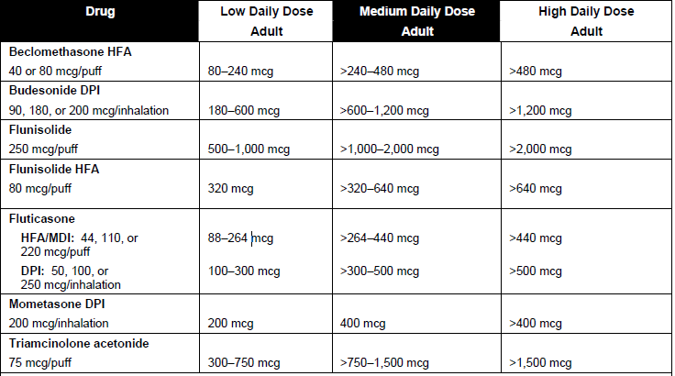
ESTIMATED COMPARATIVE DAILY DOSAGES FOR INHALED CORTICOSTEROIDS FOR YOUTHS ≥12 YEARS OF AGE AND ADULTS
(NAEPP, 2007)
Part 3: Medication Regimens and Step Approach to Asthma Management
Clinical guidelines for asthma prevention and control can be found on the Global Initiative for Asthma Report (GINA 2022) and the Asthma Management Guidelines from the National Heart, Lung, and Blood association (NAEPP Expert Panel 2007). An overview of the adult treatment algorithm can be found below for use in the general population with more specific alternatives listed in the guidelines.
The treatment of asthma is generally approached in a stepwise manner and depending on disease severity, a combination of several agents may be needed. For initial therapy, the guidelines no longer recommend a short acting beta-adrenergic inhaler (SABA) only treatment. Although inhaled SABA’s are highly effective for the quick relief of asthma symptoms, patients whose asthma is treated with SABA alone (compared with inhaled corticosteroids) are at increased risk of asthma-related death and urgent asthma-related healthcare, even if they have good symptom control. The risk of asthma exacerbations and mortality increases incrementally with higher SABA use. (GINA, 2022. P.75)

Recent updates to treatment guidelines include the use of single maintenance and reliever therapy (SMART). This therapy consists of using the same inhaler on a daily and as needed basis, consisting of inhaled corticosteroid (ICS) and long-acting beta agonist (LABA). The ICS medication reduces swelling and mucus formation in the lungs, while the LABA prevents the muscles around the airways from tightening and works immediately to open the airways. The current guidelines only recommend the combination medication budesonide/formoterol (Symbicort®) for SMART.
The target population for SMART therapy includes Individuals 4 years and older with a severe exacerbation in the prior year to reduce exacerbations. Other candidates for SMART therapy include anyone who requires use of a short acting agent for greater than 2 days per week. Inhaled corticosteroids (ICS) are the preferred long-term control therapy in asthma for all ages, although leukotriene receptor antagonists (LTRA) are listed as an alternative. The Guidelines state that the frequency of short acting beta-adrenergic inhaler (SABA) use can be clinically useful as a measure of disease activity since increased use of a SABA has been associated with increased risk for death or hospitalizations (GINA, 2022. P.35).
Stepping up asthma treatment
Asthma is a variable condition, and periodic treatment adjustments by the clinician and/or the patient may be needed.
- Day-to-day adjustment: For patients whose reliever inhaler is combination budesonide-formoterol or beclometasone-formoterol, the patient adjusts the number of as-needed doses of inhaled corticosteroid (ICS) and formoterol treatment from day to day according to their symptoms. This strategy reduces the risk of developing a severe exacerbation requiring oral corticosteroids within the next 3–4 weeks.
- Short-term step up (for 1–2 weeks): A short-term increase in maintenance inhaled corticosteroid (ICS) dose for 1–2 weeks may be necessary; for example, during viral infections or seasonal allergen exposure. This may be initiated by the patient according to their written asthma action plan or by the health care provider.
- Sustained step up (for at least 2–3 months): Although at a group level most benefit from ICS is obtained at low dose, individual ICS responsiveness varies, and some patients whose asthma is uncontrolled on low dose ICS along with long-acting beta agonist (LABA) despite good adherence and correct technique may benefit from increasing the maintenance dose to medium potency. A step up in treatment may be recommended if the symptoms are confirmed to be due to asthma; inhaler technique and adherence are satisfactory; and modifiable risk factors such as smoking have been addressed.
- Any step-up should be regarded as a therapeutic trial. If there is no response after 2–3 months, treatment should be reduced to the previous level, and alternative treatments or referral considered

Additionally, from the NAEPP (2007) report, by referring to standards for classifying asthma severity and control, a stepwise approach to treatment can be utilized:
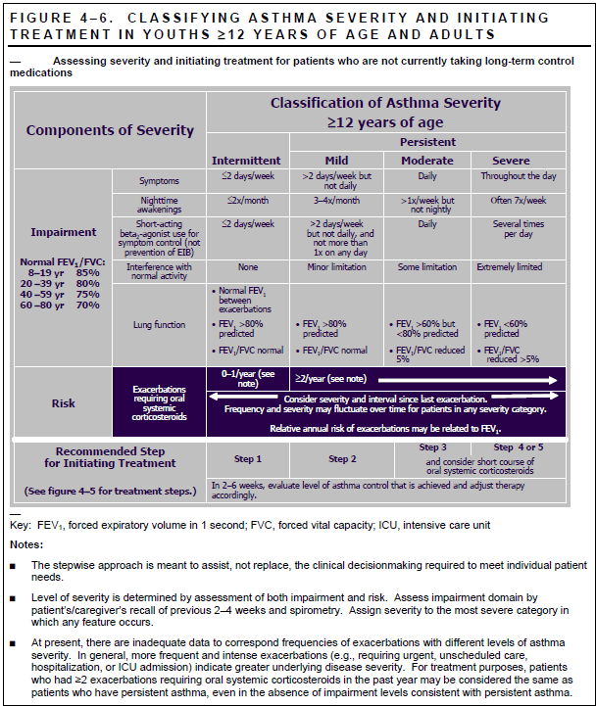

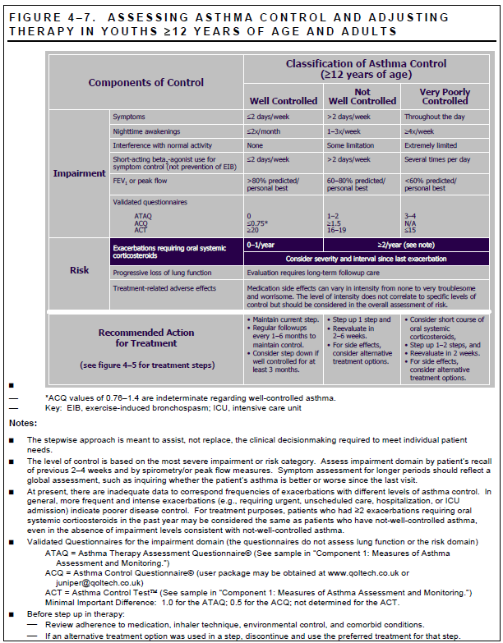

Note: From the NIHHS NIH NHLBI National Asthma Education Expert Panel Report 3: Guidelines for the Diagnosis and Management of Asthma (2007), pp. 343-345, https://www.ncbi.nlm.nih.gov/books/NBK7232/pdf/Bookshelf_NBK7232.pdf
Stepping down treatment when asthma is well controlled
Once good asthma control has been achieved and maintained for 2–3 months and lung function has reached a plateau, treatment can often be successfully reduced, without loss of asthma control. The aims of stepping down are:
- To find the patient’s minimum effective treatment: to maintain good control of symptoms and exacerbations, and to minimize the costs of treatment and potential for side-effects
- To encourage the patient to continue controller treatment: Patients often experiment with intermittent treatment through concern about the risks or costs of daily treatment, but this leaves them exposed to the risks of SABA-only treatment. For patients whose asthma is well-controlled on maintenance low dose ICS with as-needed SABA, an alternative is to cease maintenance ICS and switch to as-needed ICS-formoterol (GINA, 2022. P.74-75)

Asthma Regimens, Step Approach to Asthma Management in Adults 12 +
Step 1- Intermittent Asthma
Using ICS-formoterol as reliever- As needed low dose ICS-formoterol
Using SABA as reliever- Take ICS whenever SABA is taken
Step 2- Persistent Asthma
Using ICS-formoterol as reliever- As needed low dose ICS-formoterol
Using SABA as reliever- Low dose maintenance ICS
Step 3- Persistent Asthma, Moderate
Using ICS-formoterol as reliever-Low dose maintenance ICS-formoterol Using SABA as reliever- Low dose maintenance ICS-LABA
Step 4- Persistent Asthma, Moderate
Using ICS-formoterol as reliever-Medium dose maintenance ICS-formoterol
Using SABA as reliever- Medium/High dose maintenance ICS-LABA
Step 5- Persistent Asthma, Severe | Steps 5 and 6
Using ICS-formoterol as reliever- Add-on LAMA, refer for assessment or phenotype. Consider high dose maintenance ICS-formoterol, anti-IgE, anti-IL5/5R, anti-IL4R, anti-TSLP  Using SABA as reliever- Add-on LAMA, refer for assessment or phenotype. Consider high dose maintenance ICS-LAMA, anti-IgE, anti-IL5/5R, anti-IL4R, anti-TSLP | Consider adding Asthma Biologics
*Assess Control- First check adherence, inhaler technique, environmental factors, and comorbid conditions. Step up if needed; reassess in 2-6 weeks. Step down if possible and if asthma is well controlled for at least 3 consecutive months (GINA, 2022.)

Asthma Statistics, Clinical Data, and Recorded Measures for Disease Evaluation:
Part 1: Vermont Medicaid Global Commitment to Health Measures
The Asthma Medication Ratio measure or AMR is a Healthcare Effectiveness & Data Information Set (HEDIS) administrative measure and is included in the DVHA Global Commitment to Health Waiver performance measures. These measures illustrate how DVHA is performing in regard to use of Global Commitment to Health Waiver dollars.
Medications for asthma are usually categorized into either long-term controller medications used to achieve and maintain control of persistent asthma or quick-reliever medications used to treat acute symptoms and asthma exacerbations. The AMR measure displays ratio of controller meds to total asthma meds for Medicaid members ages 5-64. In well controlled asthma, the ratio of controller meds is greater than quick-reliever meds, which are used to treat acute symptoms and exacerbations. Higher is better on this measure with a national target of the 50th percentile. Appropriate ratios for these medications could potentially prevent a significant proportion of asthma-related costs (hospitalizations, emergency room visits, missed work and school days). This measure and additional information about it can be viewed at https://embed.clearimpact.com/Scorecard/Embed/73796.

Part 2: Prevalence and Hospitalization Rates
Since 2007, Vermont’s asthma prevalence has been higher than the national average (Asthma Surveillance in Vermont, 2022). Approximately 1 in 8 Vermont adults and 1 in 12 children have asthma. Those with disabilities are twice as likely to have asthma than those without. Vermonters insured by Medicaid have a 1.5 times higher asthma prevalence than the general Vermont population (Asthma Data Pages, 2022)
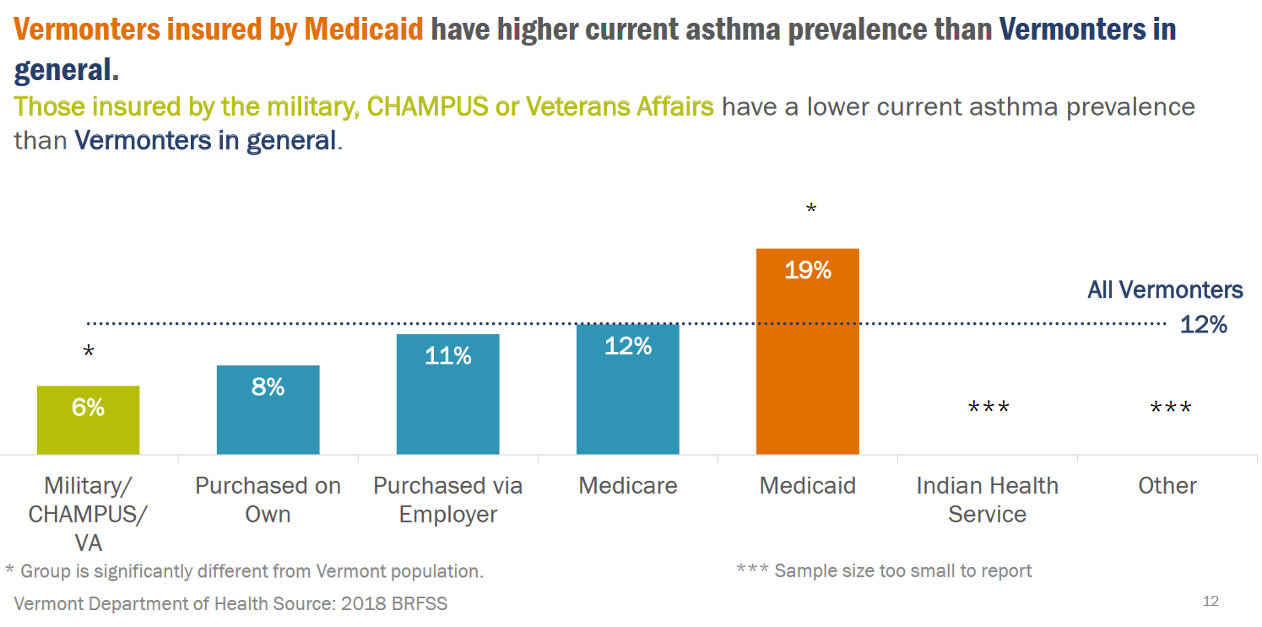
Vermont emergency department (ED) visits have remained relatively stable since 2006 at between 36 and 40 per 10,000 ED visits with asthma as their primary reason for visit. From 2009-2015 (most recent year of data collection) the rate of hospitalizations decreased by about one-third of previous admissions. Hospitalization and ED visits for primary asthma diagnosis accounted for $9million and decreased to $6.4million annually (Asthma Data Pages, 2022) Nationally, the rate of ED visits for asthma has not changed since 2010.
Nationally, asthma attacks have decreased among children and adults. Prevalence of attacks in children have decreased from 61.7% in 2001 to 44.3% in 2019, and in adults have decreased from 53.8% in 2001 to 40.4% in 2019 (CDC, 2021).
Part 3: Vermont Department of Health, Asthma Statistics
Retro Drug Utilization Review, 2019:
The Drug Utilization Review Board for Vermont periodically assesses the appropriate prescribing of certain medications across the state. A recent review labeled Appropriate Use of Asthma Controller Medications, from December 3rd 2019, was used to determine the overuse of short acting beta-adrenergic inhaler (SABA). According to the National Heart, Lung and Blood Institute guidelines for the diagnosis and management of asthma; anyone who requires use of a short acting agent > 2 days per week, a controller medication daily is recommended. The guidelines state that the frequency of SABA use can be clinically useful as a measure of disease activity since increased use of a SABA has been associated with increased risk for death or near death in patients who have asthma. Use of more than one SABA canister every one to two months is also associated with an increased risk of an acute exacerbation. Therefore, the use of more than one SABA canister (e.g., albuterol 200 puffs per canister) during a one-month period most likely indicates over reliance on this drug and suggests inadequate control of asthma. Additionally, inhaled corticosteroids (ICS) are the preferred long-term control therapy in asthma for all ages.
Data Source-Change Healthcare compiled Medicaid pharmacy claims from January 2018 through December 2018, excluding members with Part D, VMAP and Healthy Vermonters coverage.

Date Analysis- Change Healthcare reviewed Vermont paid pharmacy and medical claims with dates of service from 1/1/2018 through 12/31/2018, excluding members who had a diagnosis of cystic fibrosis, COPD or emphysema. Members were stratified by age and the number of short acting inhalers used per year. In addition, the number of members in each group who had an ER visit or hospitalization associated with an asthma diagnosis during the study period were reported. The rates of ER visits and hospitalizations were compared to the rates seen in the 2015 analysis. Additional analysis was done on those using more than 12 short acting inhalers per year.

Results- Over 13,000 members in Vermont had been prescribed short acting bronchodilators. Of those members, 235 of them were on greater than 12 inhalers per year. A third (31%) of these members on more than 12 inhalers per year were not on a controller medication (inhaled corticosteroid or alternative).

Discussion- The analysis concluded that most members using short acting bronchodilators utilized less than one inhaler per month in Vermont. There was a subset of 235 members that could be stratified into overutilizers. The overutilizers had a 31% chance of not taking a controller medication as indicated by clinical guidelines. This drug utilization review has helped Vermont Medicaid to expand prescriber notifications and education surrounding the appropriate, guidelines recommended, treatment for asthma in regard to short acting bronchodilators. (Retro Drug Utilization Review, 2019)

Guidelines and Updates:
Part 1: Approved Guidelines for Asthma Prevention and Treatment
Global Initiative for Asthma (GINA) Global Strategy for Asthma Management and Prevention: Updated 2022: https://ginasthma.org/gina-reports/
- Created by the GINA Science Committee to review and publish updates on asthma management and prevention, to evaluate the impact of this research, and to provide yearly updates. Using literature searches, systematic reviews, and discussion among the scientific community the updated guidelines provide a comprehensive treatment approach to asthma. The document and literature is reviewed twice-yearly by the GINA Science Committee and helps ensure a complete set of guidelines are available.
GINA Pocket Guide for Asthma Management and Prevention, Updated 2022- https://ginasthma.org/pocket-guide-for-asthma-management-and-prevention/
- GINA provides a summarized guide for health professionals. This easy-to-use guide enable quick reference to guidelines and peer reviewed updates for asthma treatment and prevention.
U.S. Dept Health and Human Services (USDHHS), National Institutes of Health (NIH), National Heart Lung, and Blood Institute (NHLBI), National Asthma Education and Prevention Program (NAEPP) Expert Panel Report 3: Guidelines for the Diagnosis and Management of Asthma (2007): https://www.nhlbi.nih.gov/sites/default/files/media/docs/EPR-3_Asthma_Full_Report_2007.pdf
- National guidelines report funded by the NIH NHLBI. In June 2004, a panel of experts was selected to update the clinical practice guidelines by using a systematic review of the scientific evidence for the treatment of asthma and consideration of literature on implementing the guidelines.
USDHHS NIH NHLBI NAEPP 2020 Focused Updates to the Asthma Management Guidelines: https://www.nhlbi.nih.gov/resources/2020-focused-updates-asthma-management-guidelines
- This report was developed by an Expert Panel Working Group of the National Asthma
Education and Prevention Program Coordinating Committee (NAEPPCC). The report provides updates to the 2007 to the NIH NHLBI NAEPP asthma management guidelines.

Part 2: Biologic Medications on Medicaid Preferred Drug List¹ and Clinical Efficacy
Efficacy and place in therapy- Biologics are not to be used as first line or as monotherapy but may be added on to a standard care regimen in later steps for those deemed to have severe persistent asthma with inflammatory phenotypes. Cost and coverage are the main factors limiting the usefulness of these products for asthma. Medications in this class should be given a 3-6 month trial to assess for efficacy.
DUPIXENT® (dupilumab) subcutaneous injection
Indications:
- Asthma- As an add-on maintenance treatment of adult and pediatric patients aged 6 years and older with moderate-to-severe asthma characterized by an eosinophilic phenotype or with oral corticosteroid dependent asthma.
Vermont Medicaid preferred drug list criteria:
- In addition to severe asthma, the patient must be 6 years of age or older AND the patient must have an eosinophilic phenotype as defined by pre-treatment blood eosinophil count of ≥ 150 cells per mcL within the previous 6 weeks or ≥ 300 cells per mcL within 12 months prior to initiation of therapy
- OR the patient is dependent on oral corticosteroids. The patient has a history of uncontrolled asthma symptoms (symptoms occurring almost daily or waking at night with asthma at least once a week) or 2 or more exacerbations in the previous year despite regular use of medium-high dose ICS/LABA for a minimum of 3 consecutive months, with or without oral corticosteroids.
- Pharmacy claims will be evaluated to assess compliance with therapy. AND The prescriber is an allergist, immunologist, or pulmonologist AND For continuation of therapy after the initial 6-month authorization, the patient must continue to receive therapy with an ICS/LABA AND have either a decreased frequency of exacerbations OR decreased use of maintenance oral corticosteroids OR reduction in the signs and symptoms of asthma OR an increase in predicted FEV1 from baseline.
Mechanism- Binds to interleukin-4 (IL-4) receptor, blocking both IL-4 and IL-13 signaling. The suggested initial treatment duration is at least 4 months

________________
1 The Medicaid Preferred Drug List (PDL) is updated frequently, and criteria and preferred drugs may change. The latest copy of the PDL can be found here: Preferred Drug List (PDL) & Clinical Criteria | Department of Vermont Health Access

Outcomes:
In randomized controlled trials in patients with uncontrolled severe asthma and at least one exacerbation in the last year, anti-IL4 therapy with dupilumab led to significant reduction in severe exacerbations (IRR 0.58; 95%CI 0.47 to 0.73); improvements in quality of life, symptom control and lung function were significant. (Agache et al., 2020).
In a post hoc analysis, clinical outcomes were similar in patients with allergic and non-allergic phenotype at baseline. In patients with oral corticosteroid dependent severe asthma, without minimum requirements for blood eosinophile count or FeNO, treatment with anti-IL4 therapy with dupilumab reduced mean oral corticosteroid dose by around 30% versus placebo (Rabe et al., 2018).
In children 6-11 years with eosinophilic/Type 2 asthma, dupilumab significantly reduced severe exacerbation rate (relative risk reduction in the dupilumab group, 59.3%; 95% CI, 39.5 to 72.6; P<0.001) and increased lung function by 5.2 percentage points. (Bacharier et al., 2021).
Adverse Effects: Injection-site reactions; transient blood eosinophilia; rare cases of eosinophilic granulomatosis with polyangiitis. Dupixent is not suggested for patients with baseline or historic blood eosinophile >1,500 cells/uL because of limited evidence.
FASENRA® (benralizumab) subcutaneous injection
Indications-
- Severe Asthma- Fasenra is indicated for the add-on maintenance treatment of patients with severe eosinophilic asthma aged 12 years and older Limitations of use: Fasenra is not indicated for treatment of other eosinophilic conditions. Not indicated for the relief of acute bronchospasm or status asthmaticus.
Vermont Medicaid preferred drug list criteria:
- In addition to severe asthma the patient must be 12 years of age or older for Fasenra. The patient must have a diagnosis of severe persistent asthma with an eosinophilic phenotype as defined by pre-treatment blood eosinophil count of ≥ 150 cells per mcL within the previous 6 weeks or ≥ 300 cells per mcL within 12 months prior to initiation of therapy
- AND the patient has a history of uncontrolled asthma symptoms (symptoms occurring almost daily or waking at night with asthma at least once a week) or 2 or more exacerbations in the previous year despite regular use of medium-high dose ICS/LABA for a minimum of 3 consecutive months, with or without oral corticosteroids.
- Pharmacy claims will be evaluated to assess compliance with therapy. AND The prescriber is an allergist, immunologist, or pulmonologist. For continuation of therapy after the initial 6-month authorization, the patient must continue to receive therapy with an ICS/LABA AND have either a decreased frequency of exacerbations, decreased use of maintenance oral corticosteroids, reduction in the signs and symptoms of asthma, or an increase in predicted FEV1 from baseline.
Mechanism- Binds to interleukin-5 (IL-5) receptor alpha subunit, leading to apoptosis (cell death) of eosinophils. The suggested initial treatment duration is at least 4 months
Outcomes:
Randomized controlled trials in severe asthma patients with exacerbations in the last year, with varying eosinophile criteria, anti-IL5 inhibition with benralizumab led to a significant reduction in severe exacerbations (IRR 0.63; 95%CI 0.50 to 0.81). Improvements in quality of life, lung function and symptom control were significant. Fasenra almost completely reduced blood eosinophils (Agache et al., 2020).
In a post hoc analyses, clinical outcomes with benralizumab were similar in patients with and without an allergic phenotype. In patients taking oral corticosteroids, the median dose was able to be reduced by around 50% compared to placebo (Nair et al., 2017).
Adverse Effects: injection-site reactions; anaphylaxis (rare); headache; and pharyngitis; adverse events generally similar between active treatment and placebo.
Part 3: Vermont Medicaid Nonpharmacologic Guideline Supported Care Coverage
The Asthma Guidelines-Based Care Coverage Project: Benchmarks for Key Aspects of Optimal Coverage (2020 Update) (American Lung Association, 2020) is a document that outlines guideline-based health care service coverage for asthma. These coverage recommendations are based upon the NIH NHLBI NAEPP Expert Panel Report 3: Guidelines for the Diagnosis and Management of Asthma (2007) as well as the NAEPP 2020 Focused Updates to the Asthma Management Guidelines: A Report from The National Asthma Education and Prevention Program Expert Panel Working Group (NAEPP, 2020).
The nonpharmacologic coverage benchmarks are outlined below:
Service | ALA Recommendation |  | VT Medicaid Coverage
Devices
Nebulizer | Coverage of at least one device without barriers | Covered
Peak-Flow Meters | Coverage of at least one device without  barriers | Covered
Valved-Holding Chambers | Coverage of at least two devices without barriers | Covered
Allergen Testing
Allergy Testing | Testing is covered without barriers | Covered
Allergy Treatment
Allergen Immunotherapy | Access to allergen immunotherapy without  barriers. | Covered
Lung Function Testing
Spirometry | Testing is covered without barriers |  | Covered
FeNo Testing | Testing is covered without barriers |  | Not currently a covered service however if a clinician identifies this testing as medically necessary for a member, a request for a coverage exception may be requested (Medicaid Rule 7104).
Asthma Self-Management Education | Education is covered without barriers |  | Covered

Additionally, the ALA document recommends home visits; however, at this time research around coverage for this service have been limited to pilot studies. Vermont Medicaid fee schedules are available at: http://www.vtmedicaid.com/#/feeSchedule
References:

Agache, I., Rocha, C., & Beltran, J. (2020). Efficacy and safety of treatment with biologicals (benralizumab, dupilumab and omalizumab) for severe allergic asthma: A systematic review for the EAACI Guidelines- recommendations on the use of biologicals in severe asthma. Asthma, 75, 1043-1057. doi:10.1111/all.14221
American Lung Association. (2022, November 17). Asthma Care Coverage Materials. Retrieved from American Lung Association: https://www.lung.org/getmedia/d5924757-78d8-49d6-99fa-b19070b4aacf/Asthma-Care-Coverage-Project-Benchmark
Asthma and Lung Disease. (2022). Retrieved from Vermont Department of health: https://www.healthvermont.gov/wellness/asthma
Asthma Data Pages. (2022, February). Retrieved from Vermont Department of Health: https://www.healthvermont.gov/sites/default/files/documents/pdf/HS_Asthma_Data_Pages_2022.pdf
Asthma Surveillance in Vermont. (2022, February 25). Retrieved from Vermont Department of Health : https://www.healthvermont.gov/health-statistics-vital-records/surveillance-reporting-topic/asthma
Asthma: Alternative therapy. (2022). Retrieved from Cleveland Clinic: https://my.clevelandclinic.org/health/treatments/16730-asthma-alternative-therapy
Bacharier, L., Maspero, J., Katelaris, C., Fiocchi, A., & Gagnon, R. (2021, December 9). Dupilumab in Children with Uncontrolled Moderate-to-Severe Asthma. New England Journal of Medicine, 274(24), 2230-2240. doi:DOI:10.1056/NEJMoa2106567
CDC. (2016, July 14). Asthma Control. Retrieved from Centers for Disease Control and Prevention: https://www.cdc.gov/asthma/asthma_disparities/asthma_control.htm
CDC. (2021, April 16). Asthma Data Visualizations. Retrieved from Centers for Disease Control and Prevention: https://www.cdc.gov/asthma/data-visualizations/default.htm
Global Initiative for Asthma. (2022). Global Strategy for Asthma Management and Prevention (2022 update). Retrieved from https://ginasthma.org/wp-content/uploads/2022/07/GINA-Main-Report-2022-FINAL-22-07-01-WMS.pdf
Haughney, J., Winders, T. A., Holmes, S., & Chanez, P. (2020). Global Quality Standard for Identification and Management of Severe Asthma. Advances in Therapy, 3645-3659.
Juniper, E. F., Buist, A. S., Cox, F. M., Ferrie, P., & King, D. R. (1999, May). Validation of a Standardized Version of the Asthma Quality of Life Questionnaire. CHEST, 115(5), 1265-1270. doi:10.1378/chest.115.5.1265
Medicaid Covered Services Rules. (2022). Retrieved from Vermont Agency of Human Services: https://humanservices.vermont.gov/rules-policies/health-care-rules/health-care-administrative-rules-hcar/adopted-rules
Nair, P., Wenzel, S., Rabe, K., Bourdine, A., Lugogo, N., Kuna, P., . . . Goldman, M. (2017). Oral glucocorticoid-sparing effect of benralizumab in severe asthma. New England Journal of Medicine, 376(25), 2448-2458. doi:10.1056/NEJMoa1703501
National Asthma Education and Prevention Program. (2007). Expert Panel Report 3: Guidelines for the Diagnosis and Management of Asthma. Bethesda, MD: Natonal Inisitutes of Health. Retrieved from https://www.nhlbi.nih.gov/sites/default/files/media/docs/EPR-3_Asthma_Full_Report_2007.pdf
National Asthma Education and Prevention Program. (2020). 2020 Focused Updates to the Asthma Management Guidelines. Bethesda, MD: National Institutes of Health. Retrieved from https://www.nhlbi.nih.gov/sites/default/files/publications/AsthmaManagementGuidelinesReport-2-4-21.pdf
Preferred Drug List (PDL) & Clinical Criteria. (2022, October 7). Retrieved from Department of Vermont Health Access: https://dvha.vermont.gov/providers/pharmacy/preferred-drug-list-pdl-clinical-criteria
Rabe, K., Nair, P., Brusselle, G., Maspero, J., & Castro, M. (2018, June 28). Efficacy and Safety of Dupilumab in Glucocorticoid-Dependent Severe Asthma. New England Journal of Medicine, 278(26), 2475-2485. doi:DOI:10.1056/NEJMoa1804093
Retro Drug Utilization Review. (2019). Retrieved from Department of Vermont Health Access: https://dvha.vermont.gov/advisory-boards/drug-utilization-review-board/retro-drug-utilization-review

Expert Panel Report 3: Guidelines for the Diagnosis and Management of Asthma (nih.gov)
2022 GINA Main Report - Global Initiative for Asthma - GINA (ginasthma.org)

